

Project Proposal

Introducing a Next-Level Solution - A Desktop Application to Track and Minimize Environmental Impact



Nethru randev wickramasekara

Gadse23.1f-066

NIBM



**Content**

|  |  |  |
| --- | --- | --- |
|  | **Topic** | **Page Number** |
| 1) | Introduction | 2 |
| 2) | Executive Summary | 3 |
| 3) | Project Objectives and Goals | 4 |
| 4) | Scope and Features | 5 |
| 5) | Target Audience | 7 |
| 6) | Technical Requirements | 8 |
| 7) | Architecture and Design | 10 |
| 8) | ER Diagram | 11 |
| 9) | Effective Outcomes - Based Education (OBE) Curriculum | 12 |
| 10) | Forms Design | 13 |
| 11) | References | 17 |

**Introduction**

﻿﻿﻿The environment is dealing with unprecedented challenges due to human activities, consisting of deforestation, pollution, overconsumption, and weather trade. These problems have critical effects for the fitness and properly-being of people, animals, and ecosystems. Therefore, it's miles crucial to elevate consciousness and encourage movement to shield and conserve the surroundings.

The proposed computing device application is a tool that allows customers display and decrease their environmental effect, along with carbon footprint, water consumption, and waste technology. The application will offer customers with customized remarks, tips, and recommendations on the way to adopt more eco-friendly behavior and practices. The utility will even permit customers to music their development, set goals, and evaluate their performance with others. The motive of the software is to train, inspire, and empower users to make tremendous adjustments for the surroundings and themselves.

In addition to individual benefits, the proposed computing device application contributes to large-scale efforts toward sustainability and conservation. By permitting customers to display their environmental impact in actual-time, the software fosters a sense of responsibility and collective obligation. Moreover, by promoting sustainable practices which include lowering carbon emissions, keeping water resources, and minimizing waste technology, the application aligns with global initiatives geared toward mitigating climate change and preserving herbal ecosystems.

Furthermore, the software serves as a valuable instructional tool, offering customers insights into the interconnectedness of human activities and environmental health. Through informative content material, interactive capabilities, and get entry to to relevant resources, users can deepen their knowledge of environmental problems and explore realistic answers. By empowering customers with knowledge and tools to make informed choices, the application cultivates a culture of environmental stewardship and encourages participation in broader conservation efforts.

In precis, the proposed computer application represents a proactive method to addressing environmental demanding situations and selling sustainable residing practices. By combining user-pleasant interface layout with sturdy capability, the software has the capability to make a significant impact on man or woman behaviors and collective efforts toward environmental conservation in Sri Lanka and beyond.

**Executive Summary**

﻿The primary points of the inspiration are:

* The proposed desktop application is a tool that helps customers reveal and reduce their environmental impact, consisting of carbon footprint, water intake, and waste generation.
* The software will offer customers with personalized comments, suggestions, and tips on a way to undertake more eco-friendly behavior and practices.
* The application will even allow users to track their progress, set goals, and examine their overall performance with others.

In addition to its person-centric capabilities, the proposed computing device software is designed to deal with urgent environmental issues facing Sri Lanka and the wider global community. By empowering customers to take tangible steps in the direction of sustainability, the utility objectives to mitigate the destructive effects of climate change, maintain herbal habitats, and guard the fitness and nicely-being of modern and destiny generations.

Moreover, the application's intuitive interface and information visualization talents make it available to an extensive range of users, together with people, families, agencies, and academic institutions. Through focused outreach and partnerships with neighborhood corporations and government organizations, the utility seeks to maximize its impact and reach various audiences across Sri Lanka.

Overall, the proposed computing device software represents a proactive and modern technique to promoting environmental consciousness and action. By harnessing the electricity of era and person engagement, the utility has the capability to foster high quality behavioral adjustments and make a contribution to a extra sustainable and resilient future for Sri Lanka and beyond.

**Project Objectives and Goals**

﻿The targets and goals of the application are to educate, inspire, and empower customers to make effective modifications for the surroundings and themselves.

In addition to instructing, motivating, and empowering users, the software pursuits to facilitate measurable discounts in key environmental metrics along with carbon emissions, water usage, and waste generation. By offering users with actionable insights and personalized guidelines, the application seeks to enable individuals to make knowledgeable decisions that result in tangible improvements in their environmental footprint.

Furthermore, the software strives to foster a experience of community and collaboration among users, encouraging them to proportion their progress, experiences, and success stories. Through social features including leaderboards, demanding situations, and discussion forums, the application creates supportive surroundings in which customers can change thoughts, are seeking advice, and have fun achievements collectively.

Ultimately, the overarching goal of the software is to catalyze a paradigm shift toward sustainable living practices within Sri Lanka and past. By leveraging technology to empower people and mobilize collective motion, the utility aims to make a contribution to the wider movement for environmental conservation and stewardship on a nearby, national, and international scale.

**Scope and Features**

﻿The essential functions and functionalities of the application are:

* A dashboard that shows the person’s contemporary environmental effect and development.
* A calculator that estimates the user’s carbon footprint, water consumption, and waste era based totally on their inputs and options.
* A quiz that assesses the user’s understanding and consciousness of environmental issues and solutions.
* A manual that offers the person with hints and pointers on a way to reduce their environmental effect in numerous aspects in their life, which includes transportation, strength, food, purchasing, and waste.
* A gamification gadget that rewards the user with factors, badges, and achievements for finishing obligations and demanding situations related to environmental sustainability.
* A social community that permits the consumer to proportion their results, desires, and suggestions with other users and be part of communities of hobby.

In addition to the core capabilities cited above, the utility may also comprise superior functionalities to beautify consumer engagement and effectiveness in accomplishing sustainable way of life goals. These extra capabilities encompass:

* Customizable purpose placing: Users may have the ability to set personalized environmental dreams based totally on their character choices, lifestyle, and priorities. The application will provide guidelines and music development in the direction of those goals, permitting users to modify and refine their goals through the years.
* Integration with IoT gadgets: The utility can have the functionality to connect with Internet of Things (IoT) devices along with smart meters, strength video display units, and water sensors to acquire actual-time statistics on aid consumption. This integration will offer customers with accurate insights into their environmental effect and permit more specific monitoring and optimization in their behaviors.
* Educational sources and articles: The application will provide a curated selection of instructional assets, articles, and multimedia content material on diverse environmental subjects, ranging from weather alternate and biodiversity conservation to sustainable agriculture and circular financial system standards. These assets will empower users to deepen their knowledge of environmental problems and inspire them to take action.
* Expert consultations and community occasions: Users will have the opportunity to have interaction with environmental specialists thru digital consultations, workshops, and webinars hosted inside the utility. Additionally, the utility will facilitate network events together with smooth-up drives, tree planting campaigns, and sustainability fairs to inspire offline participation and community constructing.
* Data analytics and reporting: The software will generate comprehensive reports and analytics on user behaviors, traits, and effect metrics, taking into account statistics-driven decision-making and continuous improvement. These insights can also be valuable for research, policy advocacy, and collaboration with stakeholders in the environmental sector.

By incorporating these extra functions, the software goals to provide users with a holistic and immersive enjoy that empowers them to make significant contributions toward sustainability and conservation efforts in Sri Lanka and beyond.

**Target Audience**

﻿The target audience of the application are students, teachers, and professionals who're interested by gaining knowledge of more approximately environmental sustainability and taking movement to lessen their environmental impact.

In addition to students, instructors, and specialists, the application also appeals to environmentally-aware individuals and households seeking realistic gear to adopt greater sustainable lifestyles. Furthermore, the utility is designed to deal with users with various levels of expertise and revel in in environmental troubles, presenting reachable resources and steering for both novices and professionals alike.

Moreover, the software caters to diverse demographic organizations throughout Sri Lanka, including city and rural communities, as well as unique age groups and socioeconomic backgrounds. By supplying localized content material, language guide, and culturally applicable examples, the utility guarantees inclusivity and relevance for customers across the country.

Furthermore, the software can also be used by corporations and establishments, which include faculties, companies, and non-income businesses, as an academic tool and platform for selling environmental cognizance and engagement among their individuals and stakeholders.

Overall, the large audience of the software reflects its versatility and capability to reach a wide variety of individuals and groups interested in making high quality contributions towards environmental sustainability and conservation efforts in Sri Lanka.

**Technical Requirements**

﻿﻿As a part of our commitment to environmental sustainability, we endorse the improvement of a computer software that empowers customers to monitor and reduce their environmental impact. Our application will cognizance on three vital areas: carbon footprint, water consumption, and waste technology. By providing users with actual-time statistics and actionable insights, we goal to foster accountable conduct and make a contribution to the conservation of Sri Lanka’s herbal assets, wildlife, and climate. ﻿Our computing device application will function a consumer-pleasant tool for tracking and coping with environmental metrics. Users can input applicable statistics, inclusive of each day activities, power utilization, and waste disposal conduct. The utility will then calculate their carbon footprint, water usage, and waste output. Additionally, it's going to offer personalized guidelines on how to limit environmental effect. The technical requirements of the utility are:

* ﻿To broaden this application, we've chosen IntelliJ IDEA as our desired integrated improvement surroundings (IDE). IntelliJ IDEA offers robust features for Java development, green code navigation, and seamless integration with build equipment. Leveraging IntelliJ IDEA’s abilities, we are able to create a dependable, scalable, and maintainable answer. By utilizing IntelliJ IDEA, we ensure streamlined improvement, code exceptional, and efficient collaboration among crew participants. Our dedication to the use of industry-widespread equipment displays our dedication to handing over a amazing environmental monitoring software.
* The application may be developed the usage of C# because the programming language, .NET because the framework, and Visual Studio because the IDE.
* The utility will use SQLite because the database management gadget to shop and retrieve the user’s statistics and alternatives.
* The application will use Bing Maps API to get admission to and display geographic records and records.
* The application will use Material Design because the UI design device to create a regular and intuitive person interface and interaction go with the flow.
* The software will run on Windows eleven Professional and require a minimum of four GB of RAM and 500 MB of disk space.

In addition to the noted technical specs, the utility will prioritize scalability, protection, and overall performance to ensure a continuing person revel in. To gain this, the development technique will adhere to industry exceptional practices and standards, such as code optimization, data encryption, and mistakes managing mechanisms.

Furthermore, the software will guide regular updates and upkeep to address bugs, enhance capabilities, and comprise consumer feedback. Version control structures including Git can be applied to manipulate code modifications and collaborate successfully.

Moreover, the utility can be designed with modularity and extensibility in mind, allowing for smooth integration of new functions, APIs, and 1/3-party services in destiny iterations. This flexibility will allow the utility to conform to evolving user needs and technological advancements over time.

Lastly, complete testing protocols may be applied at some stage in the development lifecycle to ensure the reliability, stability, and compatibility of the utility across unique hardware configurations and utilization situations. This will encompass unit testing, integration trying out, and person recognition trying out to validate capability and value underneath numerous situations.

By adhering to those technical necessities and ideas, the utility can be well-equipped to fulfill its venture of empowering customers to reveal and decrease their environmental effect, contributing to the sustainability and conservation efforts in Sri Lanka.

**Architecture and Design**

﻿The structure and design of the utility are:

* The application will observe the Model-View-Controller (MVC) sample to split the facts, logic, and presentation layers of the application.
* The application will encompass four fundamental modules: Dashboard, Calculator, Quiz, and Guide. Each module may have its very own version, view, and controller instructions that communicate with every other and the database.
* The application may also have a not unusual module that includes the instructions and techniques which are shared with the aid of all the different modules, which includes the person class, the gamification system, the social network, and the settings.

The following diagrams, wireframes, and mockups illustrate the person interface and interplay drift of the software.

In addition to following the MVC sample and modular structure, the utility's architecture will prioritize scalability, maintainability, and extensibility. This could be achieved through careful design decisions, which include using dependency injection to facilitate loose coupling between additives, enforcing layout styles to address not unusual software engineering demanding situations, and adhering to coding conventions and naming conventions for consistency and readability.

Furthermore, the utility's layout will prioritize user experience (UX) standards to make sure an intuitive and seamless interaction float. This consists of considerations together with responsive layout to house special display sizes and resolutions, accessibility features to cater to customers with various needs, and value checking out to become aware of and cope with any usability problems.

Moreover, the software's layout will leverage current technology and frameworks to enhance overall performance and visual attraction. This includes utilizing asynchronous programming techniques to enhance responsiveness, incorporating animation and transition consequences to beautify engagement, and employing responsive typography and color schemes to create a visually desirable aesthetic.

Lastly, the structure and design of the software might be documented comprehensively to facilitate knowledge, collaboration, and future improvement efforts. This will consist of architectural diagrams, magnificence diagrams, series diagrams, and different artifacts to illustrate the structure, behavior, and interactions of the utility additives.

By adopting a robust architecture and thoughtful design approach, the utility will be nicely-placed to fulfill the wishes of customers, stakeholders, and the broader environmental conservation network in Sri Lanka.

1)ER Diagram

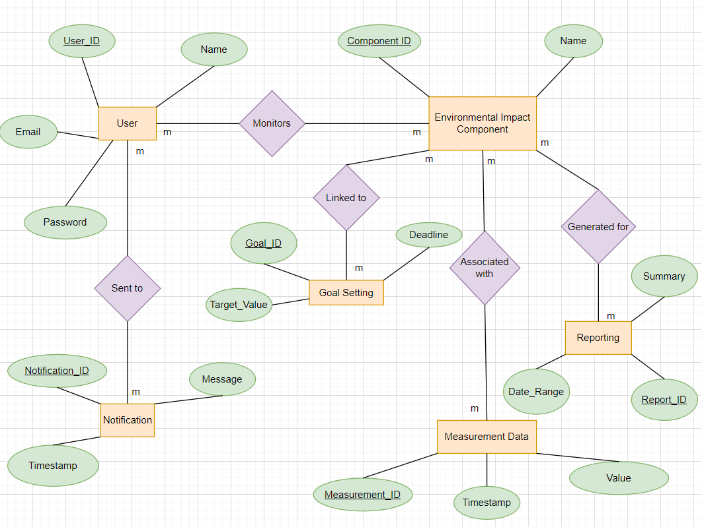

2)Effective Outcomes - Based Education (OBE) Curriculum

This proposed laptop software aims to help customers screen and reduce their environmental effect, that specialize in regions like carbon footprint, water intake, and waste era.

By following this OBE curriculum layout manner, this computer software can efficaciously contribute to Sri Lanka’s natural aid conservation and definitely have an impact on users’ behaviors.

3)Forms Design

(a)Dashboard

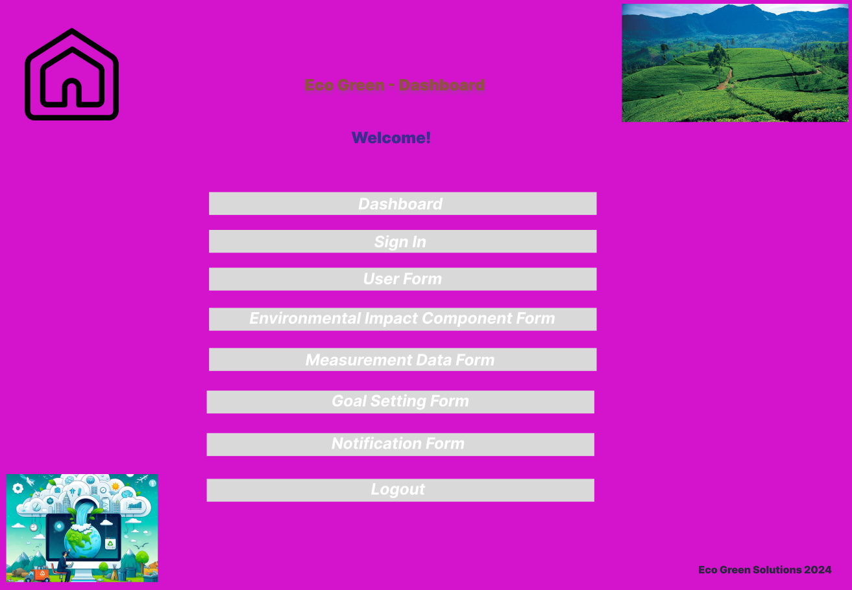

(b)Login Form

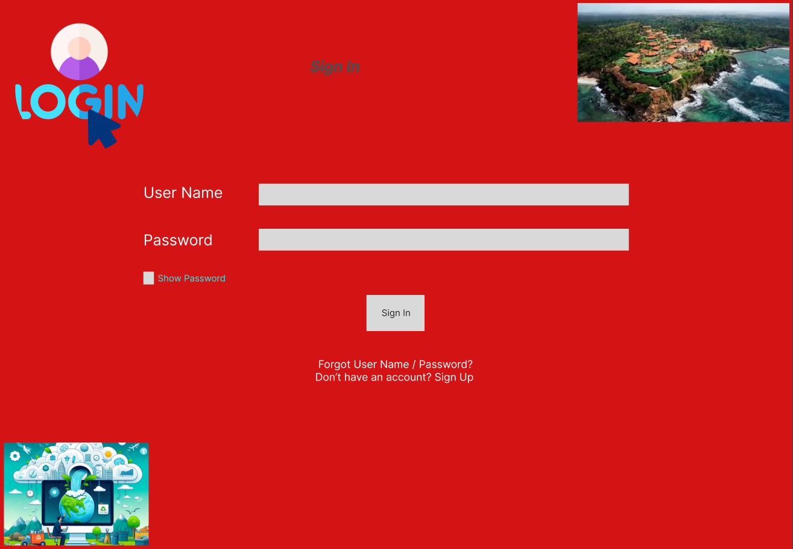

(c)User Form

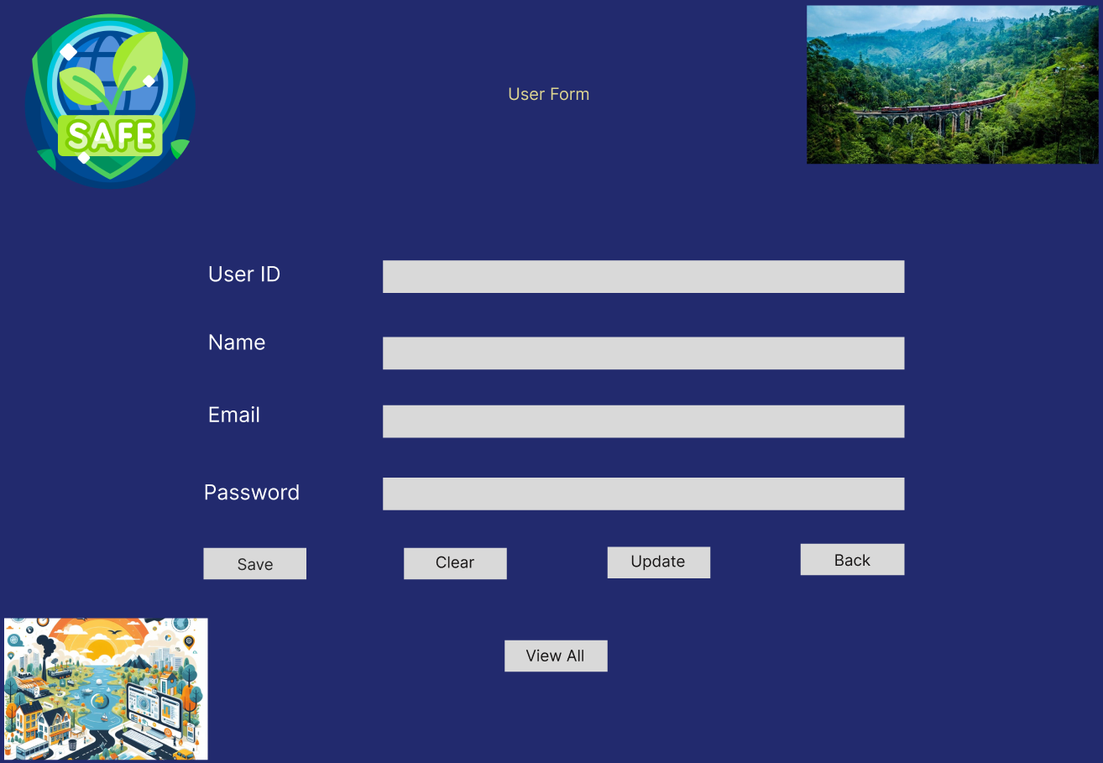

(d)Environment Impact Component Form

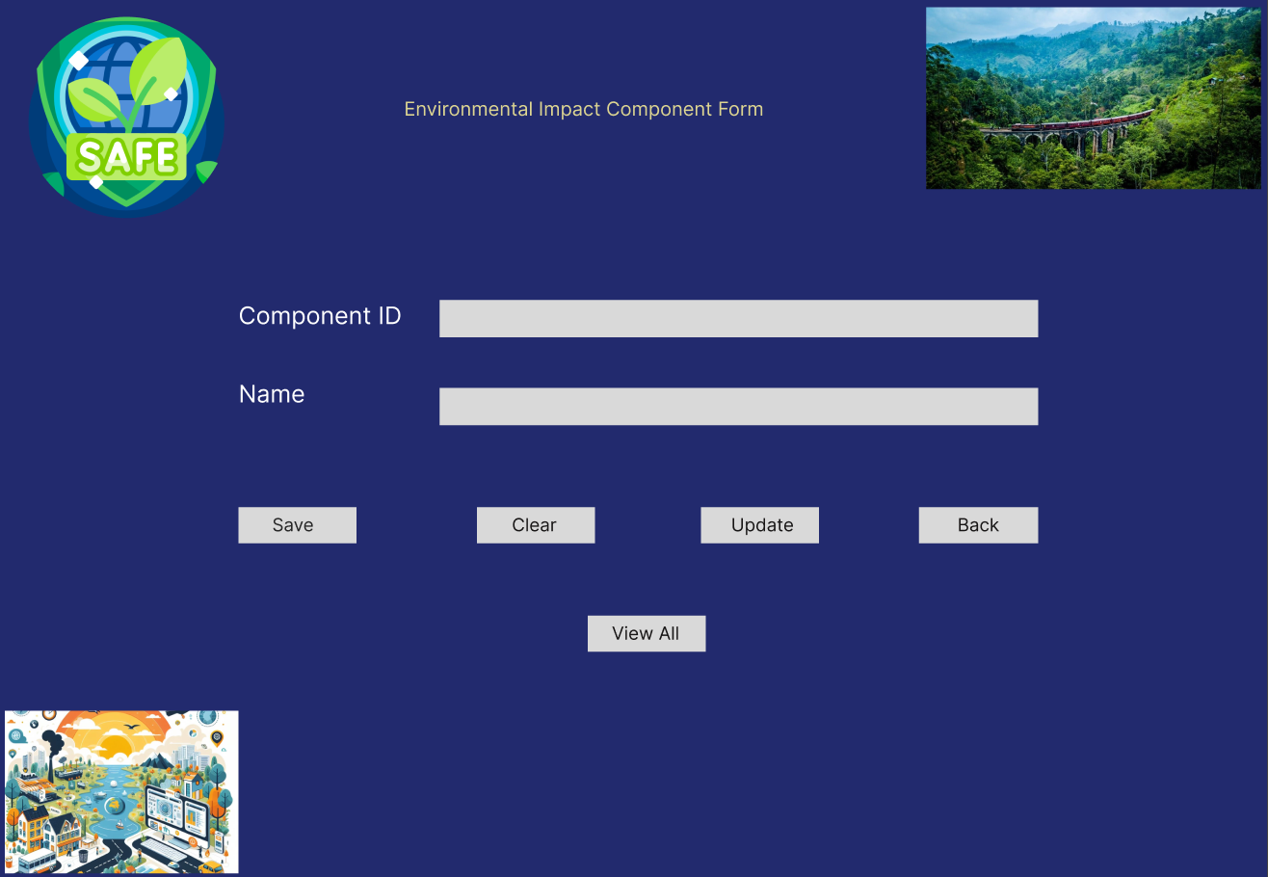

(e)Measurement Data Form

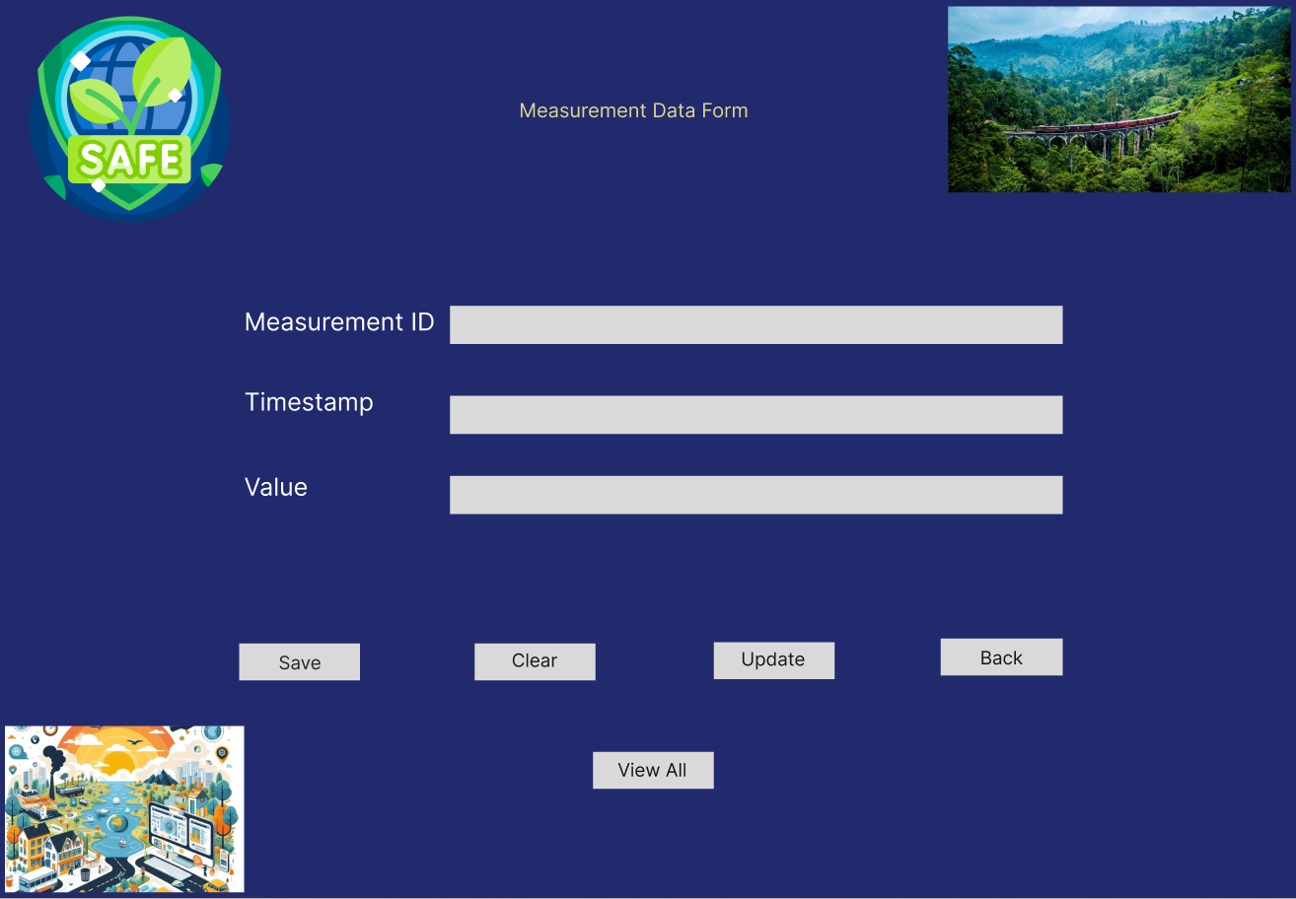

(f)Goal Setting Form

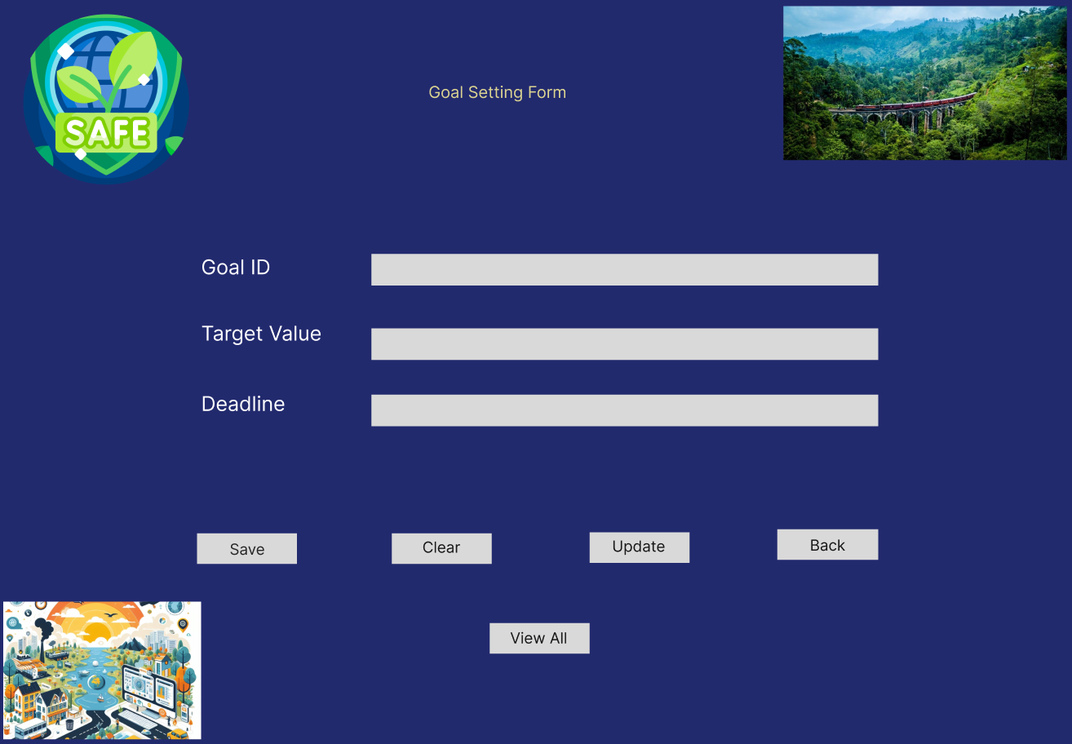

(g)Notification Form

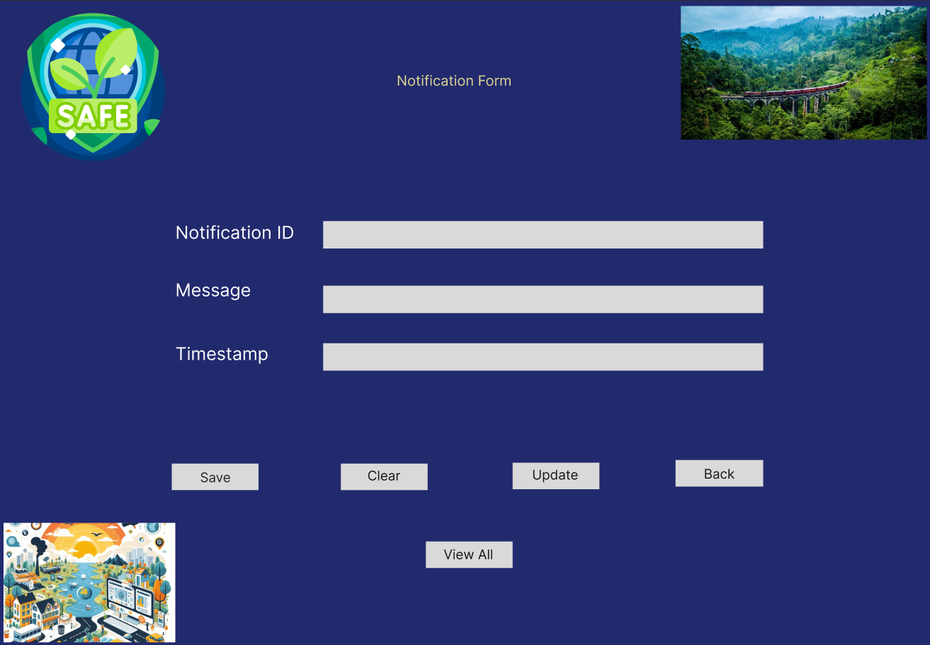

(h)Reporting Form

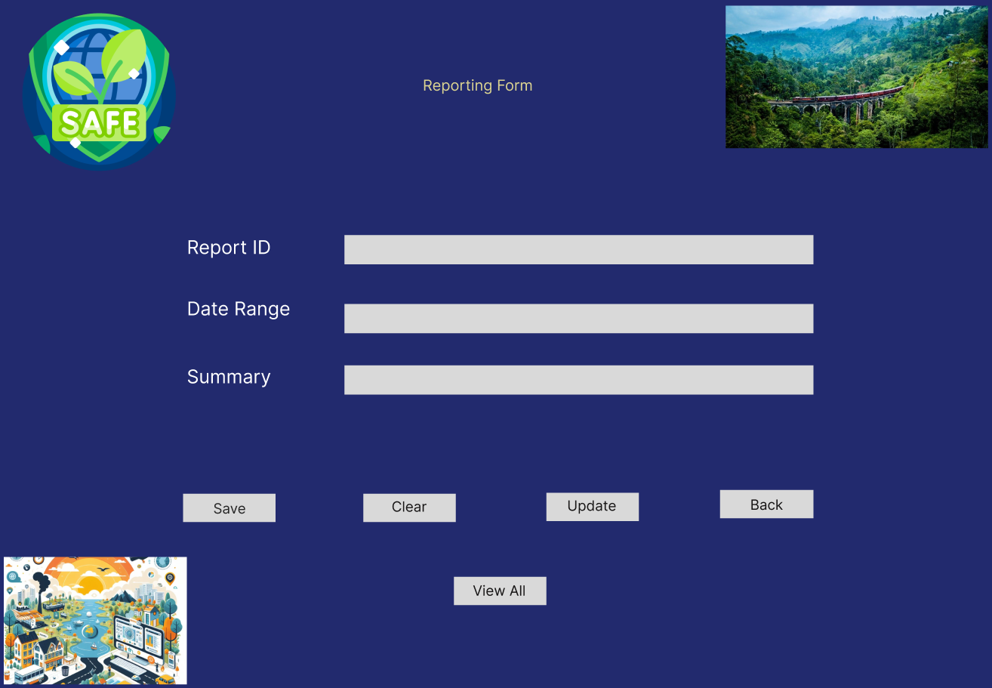

**References**

1. <https://cloud.google.com/blog/topics/sustainability/new-tools-to-measure-and-reduce-your-environmental-impact>
2. <https://www.makeuseof.com/tracking-carbon-footprint-best-apps/>
3. <https://www.computerworld.com/article/3676131/sustainable-it-environmental-and-social-approach-to-business-technology.html>
4. <https://en.wikipedia.org/wiki/Green_computing>
5. <https://www.digi.com/blog/post/iot-based-environmental-monitoring>